CHAPTER 12
Ecosystem
• Ecosystem

Ch 12 | ECOSYSTEM - Chapter Opener

Chapter contents (as printed on the opener page): 12.1 Ecosystem - Structure and Function; 12.2 Productivity; 12.3 Decomposition; 12.4 Energy Flow; 12.5 Ecological Pyramids.
• An ecosystem can be visualised as a functional unit of nature, where living organisms interact among themselves and also with the surrounding physical environment.
• Ecosystem varies greatly in size - from a small pond to a large forest or a sea.
• Many ecologists regard the entire biosphere as a global ecosystem, as a composite of all local ecosystems on Earth.
Since this system is too much big and complex to be studied at one time, it is convenient to divide it into two basic categories, namely terrestrial and aquatic.
Category | Examples (NCERT)
Terrestrial ecosystems | Forest, grassland and desert
Aquatic ecosystems | Pond, lake, wetland, river and estuary
Man-made ecosystems | Crop fields and an aquarium may also be considered as man-made ecosystems

We will first look at the structure of the ecosystem, in order to appreciate the input (productivity), transfer of energy (food chain/web, nutrient cycling) and the output (degradation and energy loss). We will also look at the relationships - cycles, chains, webs - that are created as a result of these energy flows within the system and their inter-relationship.
12.1 | ECOSYSTEM - STRUCTURE AND FUNCTION

In earlier classes, you have looked at the various components of the environment - abiotic and biotic. You studied how the individual biotic and abiotic factors affected each other and their surrounding. Let us look at these components in a more integrated manner and see how the flow of energy takes place within these components of the ecosystem.
Interaction of biotic and abiotic components results in a physical structure that is characteristic for each type of ecosystem.
Component | What it comprises (Summary)
Abiotic components | Inorganic materials - air, water and soil
Biotic components | Producers, consumers and decomposers

• Species composition: identification and enumeration of plant and animal species of an ecosystem gives its species composition.
• Stratification: vertical distribution of different species occupying different levels is called stratification. For example, trees occupy the top vertical strata or layer of a forest, shrubs the second, and herbs and grasses occupy the bottom layers.
[NOTE] Species composition and stratification are the two main structural features of an ecosystem (stated explicitly in the Summary).

The components of the ecosystem are seen to function as a unit when you consider the following four aspects, in NCERT's order:
1 | Productivity
2 | Decomposition
3 | Energy flow
4 | Nutrient cycling

12.1 | The pond as an example of an aquatic ecosystem

To understand the ethos of an aquatic ecosystem let us take a small pond as an example. This is fairly a self-sustainable unit and rather simple example that explains even the complex interactions that exist in an aquatic ecosystem. A pond is a shallow water body in which all the above-mentioned four basic components of an ecosystem are well exhibited.
Component in the pond | What it is
Abiotic | The water with all the dissolved inorganic and organic substances and the rich soil deposit at the bottom of the pond. The solar input, the cycle of temperature, day-length and other climatic conditions regulate the rate of function of the entire pond
Autotrophic components | The phytoplankton, some algae and the floating, submerged and marginal plants found at the edges
Consumers | The zooplankton, the free swimming and bottom dwelling forms
Decomposers | The fungi, bacteria and flagellates especially abundant in the bottom of the pond

This system performs all the functions of any ecosystem and of the biosphere as a whole, i.e., conversion of inorganic into organic material with the help of the radiant energy of the sun by the autotrophs; consumption of the autotrophs by heterotrophs; decomposition and mineralisation of the dead matter to release them back for reuse by the autotrophs. These events are repeated over and over again.
• There is a unidirectional movement of energy towards the higher trophic levels and its dissipation and loss as heat to the environment.
12.2 | PRODUCTIVITY

A constant input of solar energy is the basic requirement for any ecosystem to function and sustain.
• Primary production is defined as the amount of biomass or organic matter produced per unit area over a time period by plants during photosynthesis. It is expressed in terms of weight (g m⁻²) or energy (kcal m⁻²).
• The rate of biomass production is called productivity. It is expressed in terms of g m⁻² yr⁻¹ or (kcal m⁻²) yr⁻¹ to compare the productivity of different ecosystems.
Productivity can be divided into gross primary productivity (GPP) and net primary productivity (NPP).
Term | Definition
Gross primary productivity (GPP) | The rate of production of organic matter during photosynthesis. A considerable amount of GPP is utilised by plants in respiration
Net primary productivity (NPP) | Gross primary productivity minus respiration losses (R), i.e. GPP - R = NPP. NPP is the available biomass for the consumption to heterotrophs (herbivores and decomposers)
Secondary productivity | Defined as the rate of formation of new organic matter by consumers

[NOTE] NCERT's parenthetical spells it "herbiviores"; the fact is that NPP is available to herbivores AND decomposers. The Summary also states secondary productivity as the rate of assimilation of food energy by the consumers - recognise both wordings.

Primary productivity depends on the plant species inhabiting a particular area. It also depends on a variety of environmental factors, availability of nutrients and photosynthetic capacity of plants. Therefore, it varies in different types of ecosystems.
Annual net primary productivity | Value (dry weight of organic matter)
Whole biosphere | Approximately 170 billion tons
Oceans (despite occupying about 70 per cent of the surface) | Only 55 billion tons
Land | The rest, of course, is on land

[NOTE] NCERT activity: Discuss the main reason for the low productivity of ocean with your teacher.

12.3 | DECOMPOSITION

You may have heard of the earthworm being referred to as the farmer's 'friend'. This is so because they help in the breakdown of complex organic matter as well as in loosening of the soil.
• Decomposition: decomposers break down complex organic matter into inorganic substances like carbon dioxide, water and nutrients, and the process is called decomposition.
• Detritus: dead plant remains such as leaves, bark, flowers and dead remains of animals, including fecal matter, constitute detritus, which is the raw material for decomposition.
The important steps in the process of decomposition are (in NCERT's order):
1 | Fragmentation - detritivores (e.g., earthworm) break down detritus into smaller particles.
2 | Leaching - water-soluble inorganic nutrients go down into the soil horizon and get precipitated as unavailable salts.
3 | Catabolism - bacterial and fungal enzymes degrade detritus into simpler inorganic substances.
4 | Humification - leads to accumulation of humus (see below).
5 | Mineralisation - the humus is further degraded to release inorganic nutrients (see below).

[NOTE] It is important to note that all the above steps in decomposition operate simultaneously on the detritus (Figure 12.1). Humification and mineralisation occur during decomposition in the soil.

• Humification leads to accumulation of a dark coloured amorphous substance called humus that is highly resistant to microbial action and undergoes decomposition at an extremely slow rate. Being colloidal in nature it serves as a reservoir of nutrients.
• Mineralisation: the humus is further degraded by some microbes and release of inorganic nutrients occurs by this process.
[NOTE] Five vs three - a discrepancy to know: the body lists FIVE steps (fragmentation, leaching, catabolism, humification and mineralisation), but the Summary says decomposition involves THREE processes - fragmentation of detritus, leaching and catabolism. Both wordings are NCERT's; do not reconcile them - recognise either in a question.

Decomposition is largely an oxygen-requiring process. The rate of decomposition is controlled by chemical composition of detritus and climatic factors:
Factor | Effect on the rate of decomposition
Chemical composition of detritus | In a particular climatic condition, decomposition is slower if detritus is rich in lignin and chitin, and quicker if detritus is rich in nitrogen and water-soluble substances like sugars
Climatic factors (temperature and soil moisture) | The most important climatic factors; they regulate decomposition through their effects on the activities of soil microbes. Warm and moist environment favour decomposition, whereas low temperature and anaerobiosis inhibit decomposition, resulting in build up of organic materials

The decomposition cycle in a terrestrial ecosystem (Figure 12.1) reads as follows: a tree grows in the soil; a green leaf falls to the ground; some are eaten by insects and other animals, so that nutrients and energy enter the food web; some nutrients leach into soil by chemical action; leaves partially consumed by decomposers such as fungi and bacteria begin to lose form and become litter; there is further decomposition by earthworms, bacteria, soil mites, fungi, etc.; and the end result is organic rich soil.
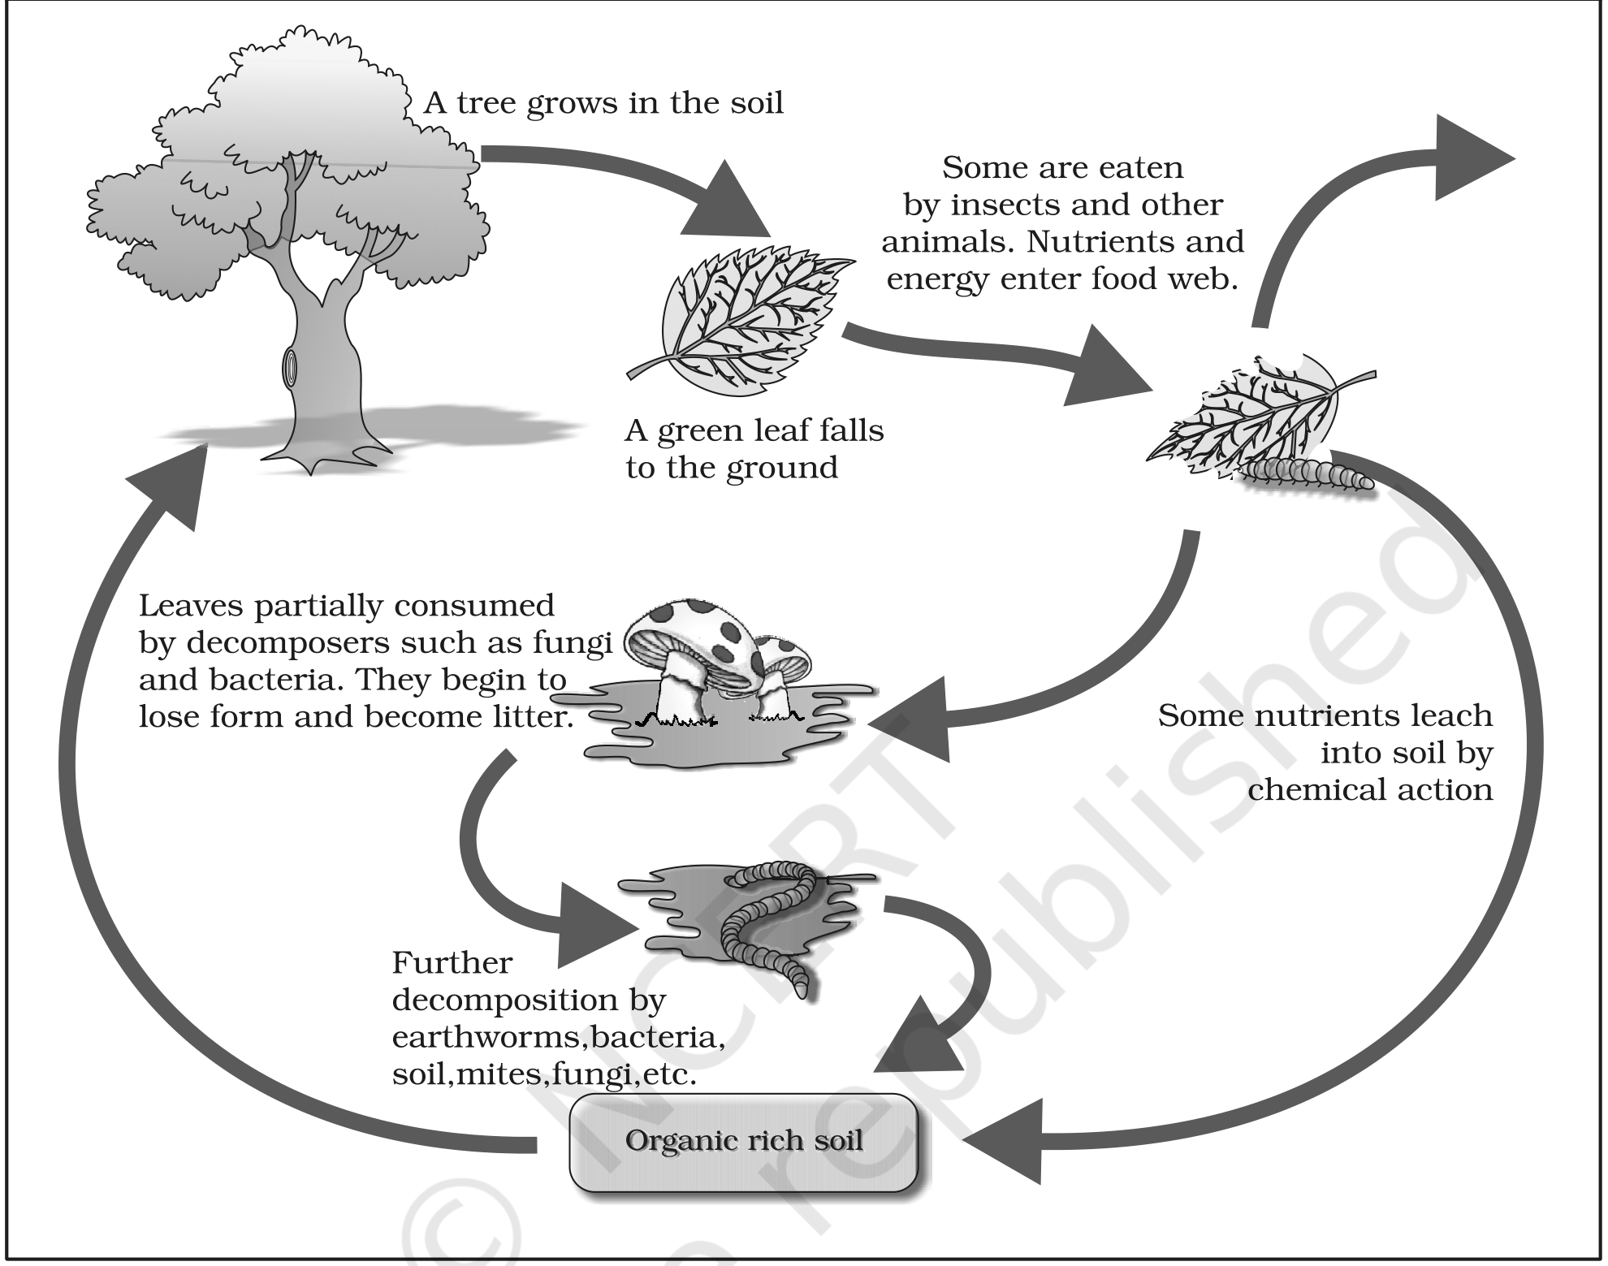
Fig. 12.1 - Diagrammatic representation of decomposition cycle in a terrestrial ecosystem.
12.4 | ENERGY FLOW

• Except for the deep sea hydro-thermal ecosystem, the sun is the only source of energy for all ecosystems on Earth. Of the incident solar radiation, less than 50 per cent of it is photosynthetically active radiation (PAR).
Plants and photosynthetic bacteria (autotrophs) fix the Sun's radiant energy to make food from simple inorganic materials. Plants capture only 2-10 per cent of the PAR, and this small amount of energy sustains the entire living world.
So it is very important to know how the solar energy captured by plants flows through different organisms of an ecosystem. All organisms are dependent for their food on producers, either directly or indirectly. So you find a unidirectional flow of energy from the sun to producers and then to consumers.
[NOTE] Thermodynamics: Is this in keeping with the first law of thermodynamics? Ecosystems are not exempt from the Second Law of thermodynamics either - they need a constant supply of energy to synthesise the molecules they require, to counteract the universal tendency toward increasing disorderliness.

• Producers: the green plants in the ecosystem are called producers. In a terrestrial ecosystem, major producers are herbaceous and woody plants. In an aquatic ecosystem producers are various species like phytoplankton, algae and higher plants.
Starting from the plants (or producers), food chains or rather webs are formed such that an animal feeds on a plant or on another animal and in turn is food for another. The chain or web is formed because of this interdependency.
• No energy that is trapped into an organism remains in it for ever. The energy trapped by the producer is either passed on to a consumer or the organism dies.
• Death of an organism is the beginning of the detritus food chain/web.
• Consumers (heterotrophs): all animals depend on plants (directly or indirectly) for their food needs, hence they are called consumers and also heterotrophs.
Consumer category | Definition (NCERT)
Primary consumers | Animals that feed on the producers (the plants). Obviously the primary consumers will be herbivores
Secondary consumers | Animals that eat other animals which in turn eat the plants (or their produce). You could have tertiary consumers too
Primary carnivores | The consumers that feed on herbivores are carnivores, or more correctly primary carnivores (though secondary consumers)
Secondary carnivores | Those animals that depend on the primary carnivores for food

• Some common herbivores are insects, birds and mammals in the terrestrial ecosystem and molluscs in the aquatic ecosystem.
A simple grazing food chain (GFC) is depicted below:
1 | Grass (Producer)
2 | Goat (Primary Consumer)
3 | Man (Secondary consumer)

• Detritus food chain (DFC) begins with dead organic matter. It is made up of decomposers, which are heterotrophic organisms, mainly fungi and bacteria. They meet their energy and nutrient requirements by degrading dead organic matter or detritus. These are also known as saprotrophs (sapro: to decompose).
• Decomposers secrete digestive enzymes that break down dead and waste materials into simple, inorganic materials, which are subsequently absorbed by them.
Ecosystem | Dominant energy-flow route
Aquatic ecosystem | GFC is the major conduit for energy flow
Terrestrial ecosystem | A much larger fraction of energy flows through the detritus food chain than through the GFC

The detritus food chain may be connected with the grazing food chain at some levels: some of the organisms of DFC are prey to the GFC animals, and in a natural ecosystem some animals like cockroaches, crows, etc., are omnivores. These natural interconnections of food chains make it a food web.
[NOTE] NCERT prompt: How would you classify human beings!

• Trophic level: organisms occupy a place in the natural surroundings or in a community according to their feeding relationship with other organisms. Based on the source of their nutrition or food, organisms occupy a specific place in the food chain that is known as their trophic level.
Trophic levels in an ecosystem (Figure 12.2): producers belong to the first trophic level, herbivores (primary consumer) to the second, and carnivores (secondary consumer) to the third. The important point to note is that the amount of energy decreases at successive trophic levels.
Trophic level | Category | Organism type | Examples
First trophic level | Producer | Plants | Phytoplankton, grass, trees
Second trophic level | Primary Consumer | Herbivore | Zooplankton, grasshopper and cow
Third trophic level | Secondary Consumer | Carnivore | Birds, fishes wolf
Fourth Trophic level | Tertiary Consumer | Top Carnivore | Man, lion

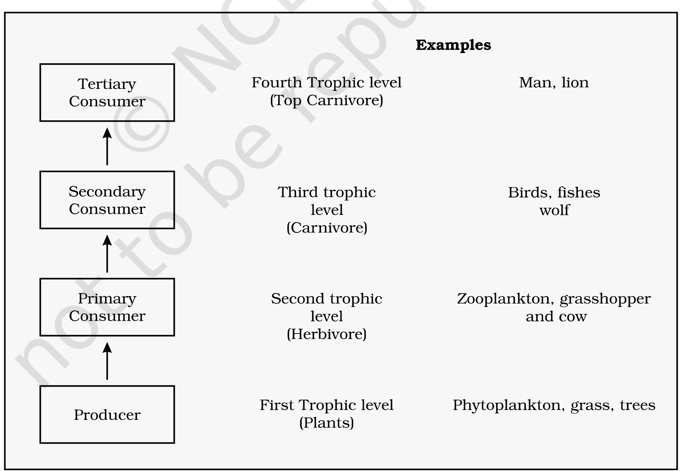
Fig. 12.2 - Diagrammatic representation of trophic levels in an ecosystem.
When any organism dies it is converted to detritus or dead biomass that serves as an energy source for decomposers. Organisms at each trophic level depend on those at the lower trophic level for their energy demands.
• Standing crop: each trophic level has a certain mass of living material at a particular time called the standing crop. It is measured as the mass of living organisms (biomass) or the number in a unit area.
• The biomass of a species is expressed in terms of fresh or dry weight. Measurement of biomass in terms of dry weight is more accurate. (NCERT prompt: Why?)
• 10 per cent law: the number of trophic levels in the grazing food chain is restricted as the transfer of energy follows the 10 per cent law - only 10 per cent of the energy is transferred to each trophic level from the lower trophic level.
In nature, it is possible to have so many levels - producer, herbivore, primary carnivore, secondary carnivore - in the grazing food chain (Figure 12.3). (NCERT prompt: Do you think there is any such limitation in a detritus food chain?)
Energy flow through different trophic levels (Figure 12.3): energy from the Sun enters the first trophic level producers (plants), passes to the second trophic level primary consumers (herbivores), then to the third trophic level secondary consumers (carnivores) and the fourth trophic level tertiary consumers (top carnivores); at every step some energy is lost as Heat.
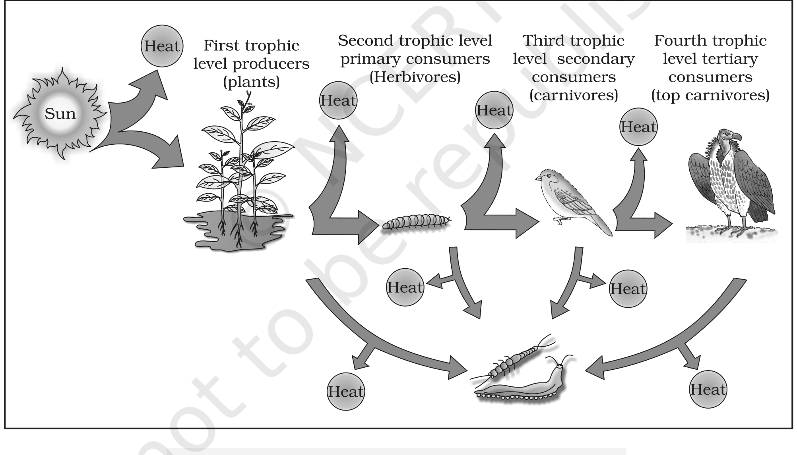
Fig. 12.3 - Energy flow through different trophic levels. The original colour figure separates the trophic levels by hue; after monochrome conversion they are read by their position, labels and the Sun/Heat markers.
12.5 | ECOLOGICAL PYRAMIDS

You must be familiar with the shape of a pyramid: the base is broad and it narrows towards the apex. One gets a similar shape whether you express the food or energy relationship between organisms at different trophic levels. This relationship is expressed in terms of number, biomass or energy.
• The base of each pyramid represents the producers or the first trophic level, while the apex represents the tertiary or top level consumer.
The three types of ecological pyramids that are usually studied are (a) pyramid of number; (b) pyramid of biomass; and (c) pyramid of energy (for detail see Figure 12.4 a, b, c and d).
• Any calculations of energy content, biomass or numbers has to include all organisms at that trophic level. No generalisations we make will be true if we take only a few individuals at any trophic level into account.
• A given organism may occupy more than one trophic level simultaneously. One must remember that the trophic level represents a functional level, not a species as such.
• For example, a sparrow is a primary consumer when it eats seeds, fruits, peas, and a secondary consumer when it eats insects and worms. (NCERT prompt: Can you work out how many trophic levels human beings function at in a food chain?)
In most ecosystems, all the pyramids - of number, of energy and biomass - are upright, i.e., producers are more in number and biomass than the herbivores, and herbivores are more in number and biomass than the carnivores. Also, energy at a lower trophic level is always more than at a higher level.
The values shown in the four pyramids of Figure 12.4 (every bar value carried verbatim; P = Producer, PC = Primary consumer, SC = Secondary consumer, TC = Tertiary consumer):
Trophic level | (a) Pyramid of numbers, grassland: Number of individuals | (b) Pyramid of biomass, grassland: Dry weight (kg m⁻²) | (c) Inverted pyramid of biomass (aquatic) | (d) Pyramid of energy
P (Producer) | 5,842,000 | 809 | 4 | 10,000 J
PC (Primary consumer) | 708,000 | 37 | 21 | 1000 J
SC (Secondary consumer) | 3,54,000 | 11 | - | 100 J
TC (Tertiary consumer) | 3 | 1.5 | - | 10 J

[NOTE] Figure 12.4 caption facts: (a) Only three top-carnivores are supported in an ecosystem based on production of nearly 6 millions plants - the bar itself reads 5,842,000 (carry both, do not reconcile). (d) An ideal pyramid of energy: primary producers convert only 1% of the energy in the sunlight available to them into NPP, out of 1,000,000 J of Sunlight.

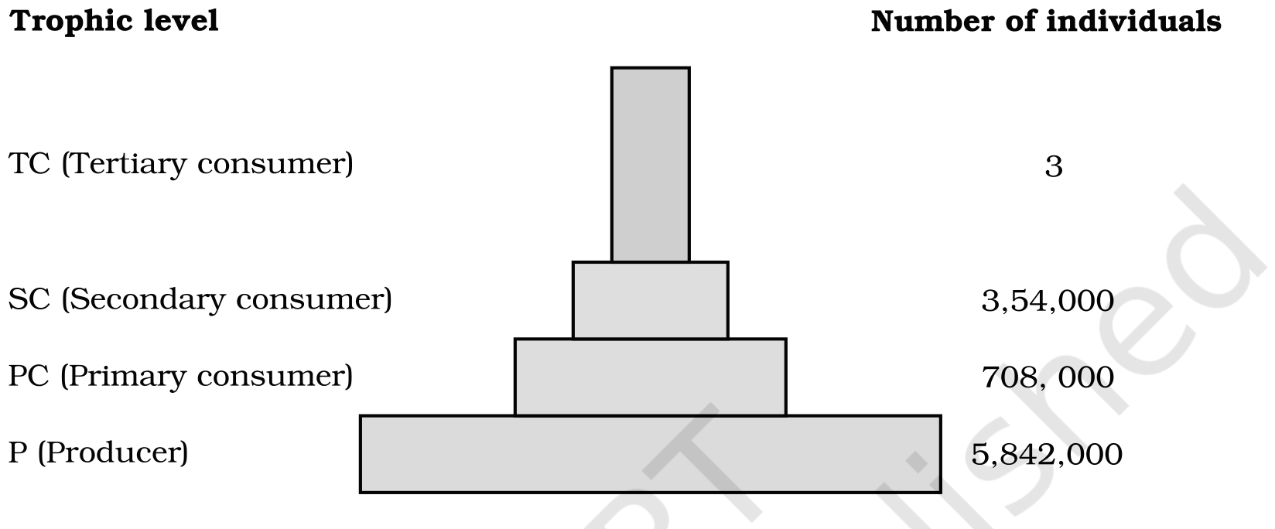
Fig. 12.4 (a) - Pyramid of numbers in a grassland ecosystem. Only three top-carnivores are supported in an ecosystem based on production of nearly 6 millions plants.
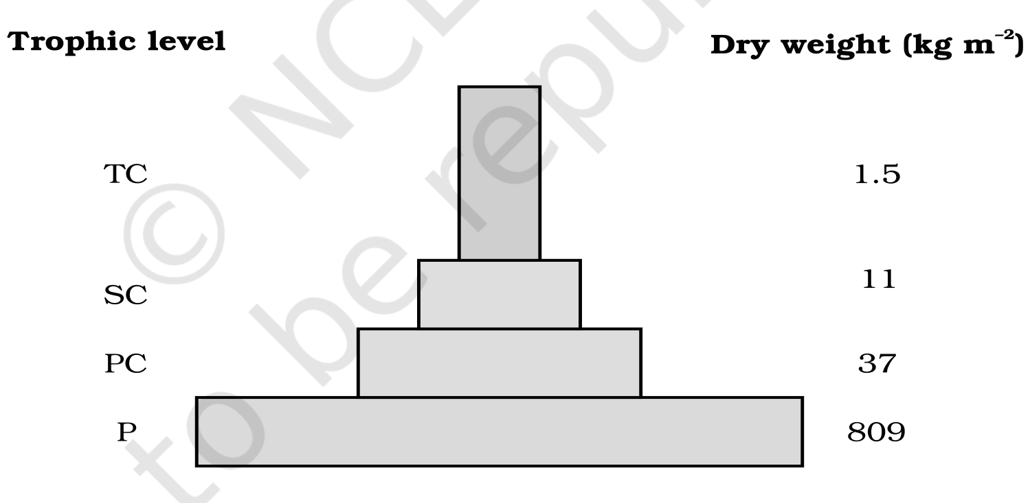
Fig. 12.4 (b) - Pyramid of biomass shows a sharp decrease in biomass at higher trophic levels.
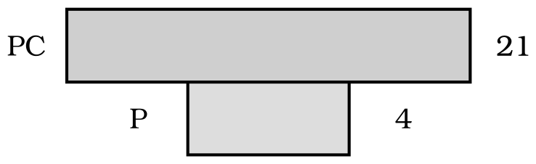
Fig. 12.4 (c) - Inverted pyramid of biomass - small standing crop of phytoplankton supports large standing crop of zooplankton.
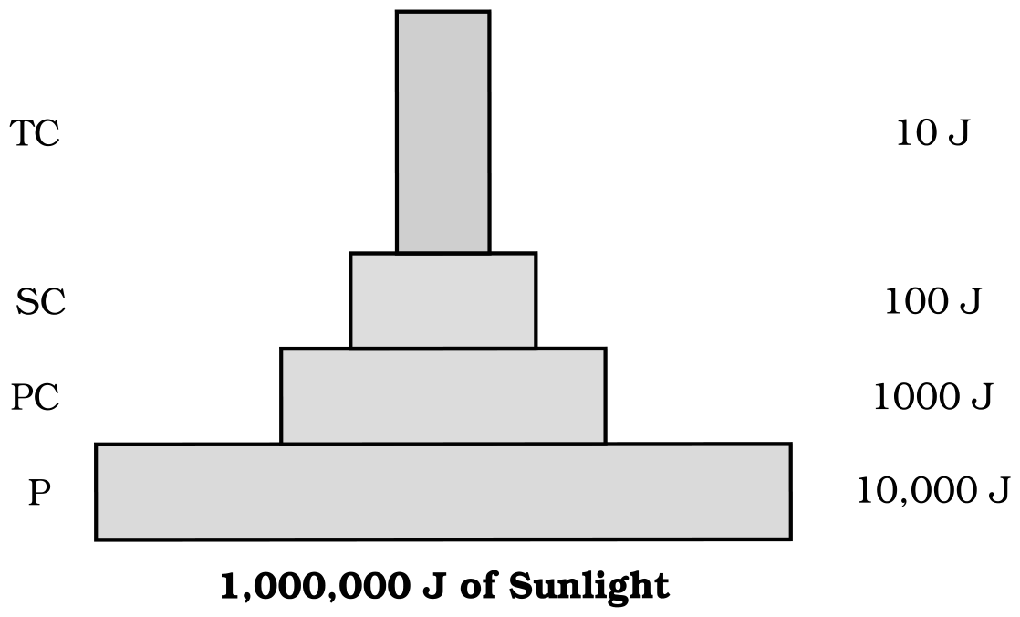
Fig. 12.4 (d) - An ideal pyramid of energy. Observe that primary producers convert only 1% of the energy in the sunlight available to them into NPP.
There are exceptions to the "pyramids are upright" generalisation:
• Pyramid of numbers on a big tree: if you count the number of insects feeding on a big tree, then add the small birds depending on the insects and the larger birds eating the smaller, the pyramid of numbers you get is not upright (it is inverted/spindle-shaped). (NCERT asks you to draw it.)
• Pyramid of biomass in the sea is generally inverted because the biomass of fishes far exceeds that of phytoplankton. (NCERT prompt: Isn't that a paradox? How would you explain this?)
• Pyramid of energy is always upright, can never be inverted, because when energy flows from a particular trophic level to the next, some energy is always lost as heat at each step.
• Each bar in the energy pyramid indicates the amount of energy present at each trophic level in a given time or annually per unit area.
[NOTE] Limitations of ecological pyramids: (1) it does not take into account the same species belonging to two or more trophic levels; (2) it assumes a simple food chain, something that almost never exists in nature, and does not accommodate a food web; (3) saprophytes are not given any place in ecological pyramids even though they play a vital role in the ecosystem.

12.6 | NUTRIENT CYCLING AND ECOSYSTEM SERVICES

[NOTE] This section carries facts stated only in the NCERT Summary - nutrient cycling is listed as one of the four functions in 12.1 but is never defined in the body, so it is folded in here.

• Nutrient cycling: the storage and movement of nutrient elements through the various components of the ecosystem is called nutrient cycling; nutrients are repeatedly used through this process.
Type of nutrient cycle | Reservoir (Summary)
Gaseous type (e.g., carbon) | Atmosphere or hydrosphere
Sedimentary type (e.g., phosphorus) | Earth's crust

• Ecosystem services: the products of ecosystem processes are named ecosystem services - e.g., purification of air and water by forests.
Recap | QUICK RECAP

• An ecosystem is a structural and functional unit of nature comprising abiotic components (inorganic materials - air, water, soil) and biotic components (producers, consumers, decomposers). Each ecosystem has a characteristic physical structure from the interaction of these components.
• Species composition and stratification are the two main structural features of an ecosystem. Based on the source of nutrition, every organism occupies a place in an ecosystem.
• Productivity, decomposition, energy flow and nutrient cycling are the four important functions/components of an ecosystem.
• Primary productivity is the rate of capture of solar energy or biomass production of the producers. GPP is the total production of organic matter; NPP is the remaining biomass/energy left after utilisation by producers (GPP - R). Secondary productivity is the rate of assimilation of food energy by the consumers.
• In decomposition, complex organic compounds of detritus are converted to carbon dioxide, water and inorganic nutrients by the decomposers. The body lists five steps; the Summary names three - fragmentation, leaching and catabolism.
• Energy flow is unidirectional: first, plants capture solar energy, and then food is transferred from the producers to decomposers. Organisms of different trophic levels are connected for food/energy, forming a food chain and food web.
• Nutrient cycling is the storage and movement of nutrients through the ecosystem; it is of two types - gaseous (reservoir: atmosphere/hydrosphere, e.g. carbon) and sedimentary (reservoir: Earth's crust, e.g. phosphorus). Ecosystem services are the products of ecosystem processes, e.g. purification of air and water by forests.
Appendix | TERMS USED IN THE EXERCISES

NCERT's eleven exercise questions assume a few terms/facts the chapter never states outright. Everything below is built only from statements already made in this chapter (plus the Summary).
Term / fact assumed | Explanation (from this chapter)
Litter (Ex 6(e): distinguish litter and detritus) | The body never defines litter; it appears only in Figure 12.1. Litter = freshly fallen, still-recognisable dead plant/animal material on the soil surface, which - as decomposers begin to consume it - loses form and becomes part of the detritus (all dead plant/animal remains that are the raw material for decomposition)
Limiting factor for productivity in aquatic ecosystems (Ex 1(c)) | The body only asks you to discuss low ocean productivity. The limiting factor is light (and nutrient) availability in water, tied to the ocean's low 55-billion-ton productivity despite its large area
Major reservoir of carbon on earth (Ex 1(e)) | From the nutrient-cycling block: carbon follows a gaseous cycle whose reservoir is the atmosphere or hydrosphere
Secondary producers (Ex 4) | The term appears nowhere in the chapter; NCERT uses secondary productivity and primary/secondary consumers. As there is no such category, the intended answer is (d) None of the above
Pyramid of numbers in a tree-dominated ecosystem (Ex 1(b)) | Posed as an activity in NCERT. The pyramid is inverted / spindle-shaped, the same non-upright case as the big-tree/insects/birds example

Appendix | NCERT Exercises (for reference)

1. Fill in the blanks: (a) Plants are called autotrophs/producers because they fix carbon dioxide; (b) in an ecosystem dominated by trees, the pyramid of numbers is inverted/spindle type; (c) in aquatic ecosystems, the limiting factor for productivity is light; (d) common detritivores are earthworms; (e) the major reservoir of carbon on earth is the atmosphere or hydrosphere (the gaseous-cycle reservoir).
2-5 (MCQ): 2. Largest population in a food chain - (a) Producers. 3. The second trophic level in a lake - (b) Zooplankton. 4. Secondary producers are - (d) None of the above. 5. Percentage of PAR in incident solar radiation - (b) 50% (NCERT states "less than 50 per cent").
6. Distinguish between: (a) Grazing food chain and detritus food chain; (b) Production and decomposition; (c) Upright and inverted pyramid; (d) Food chain and Food web; (e) Litter and detritus; (f) Primary and secondary productivity - all covered above.
7-11 (long answers): 7. Describe the components of an ecosystem. 8. Define ecological pyramids and describe, with examples, pyramids of number and biomass. 9. What is primary productivity? Describe factors that affect it. 10. Define decomposition and describe its processes and products. 11. Give an account of energy flow in an ecosystem - all answered by the sections above.
Every fact, number, name, qualifier, table row, figure and figure label in NCERT Class 12 Chapter 12 is carried above. Nothing outside the source chapter has been added.

